1. Write a program which reads a string from a user and the string comprised of eyes of three dies :

Eg S= “O-O/O-O/O-O, O--/---/--O, ---/-0-/---“.

‘O’ represents the eyes of the dies. Three rows separated by / .

Three dies values are separated by comma. Print the value of each die

For the above example the values of three dies are V=[6,2,1].

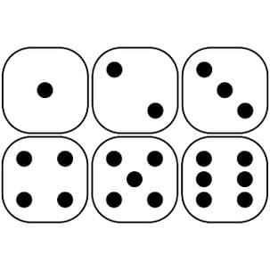

1. Write a program that takes a list of register numbers of VIT university.All valid register numbers are formed into three sets for each branch like ( MTech software engineering(MIS) , MCA(MCA), Btech(BCE)). Count and display how many students are there in each category and display how many invalid register numbers are there.
2. Write a program that takes list of land line phone numbers ( with the std code) from user . count and display how many are numbers are in each state ( take any five state of your choice). Create a tuple for each state and combine all tuples into a list and print.